# **How to build an IR Sensor**

# What is an IR sensor?

An IR sensor is a device which detects IR radiation falling on it. There are numerous types of IR sensors that are built and can be built depending on the application. Proximity sensors (Used in Touch Screen phones and Edge Avoiding Robots), contrast sensors (Used in Line Following Robots) and obstruction counters/sensors (Used for counting goods and in Burglar Alarms) are some examples, which use IR sensors.

# Working Mechanism

An IR sensor is basically a device which consists of a pair of an IR LED and a photodiode which are collectively called a photo-coupler or an opto-coupler. The IR LED emits IR radiation, reception and/or intensity of reception of which by the photodiode dictates the output of the sensor. Now, there are so many ways by which the radiation may or may not be able to reach the photodiode. Let’s discuss a few.

## Direct incidence

We may hold the IR LED directly in front of the photodiode, such that almost all the radiation emitted, reaches the photodiode. This creates an invisible line of IR radiation between the IR LED and the photodiode. Now, if an opaque object is placed obstructing this line, the radiation will not reach the photodiode and will get either reflected or absorbed by the obstructing object. This mechanism is used in object counters and burglar alarms.

## Indirect Incidence

High school physics taught us that black color absorbs all radiation, and the color white reflects all radiation. We use this very knowledge to build our IR sensor. If we place the IR LED and the photodiode side by side, close together, the radiation from the IR LED will get emitted straight in the direction to which the IR LED is pointing towards, and so is the photodiode, and hence there will be no incidence of the radiation on the photodiode. Please refer to the right part of the illustration given below for better understanding. But, if we place an opaque object in front the two, two cases occur:

### Reflective Surface

If the object is reflective, (White or some other light color), then most of the radiation will get reflected by it, and will get incident on the photodiode. For further understanding, please refer to the left part of the illustration below.

### Non-reflective Surface

If the object is non-reflective, (Black or some other dark color), then most of the radiation will get absorbed by it, and will not become incident on the photodiode. It is similar to there being no surface (object) at all, for the sensor, as in both the cases, it does not receive any radiation.

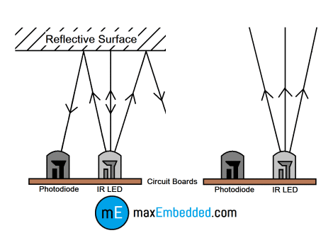

## Line Follower Robots

IR sensors are the main triggers of the whole line following robot’s action mechanism. IR sensors are the ones which detect the color of the surface underneath it and send a signal to the microcontroller or the main circuit which then takes decisions according to the algorithm set by the creator of the bot. The sensors used in them are based on **reflective/non-reflective indirect incidence**. The IR LED emits IR radiation, which in normal state gets reflected back to the module from the white surface around the black line, which gets incident on the photodiode. But, as soon as the IR radiation falls on the black line, the IR radiation gets absorbed completely by the black color, and hence there is no reflection of the IR radiation going back to the sensor module.

# What do we need?

1. IR LED
2. Photodiode
3. LM-358M (Op-Amp)
4. 2 x 150 Ω Resistance
5. 1 x 10 kΩ Resistance
6. 1 x 10 kΩ Variable Resistance (Potentiometer/Preset)
7. 5 Volt power source
8. Wires
9. General purpose PCB or bread board (Picture Below)

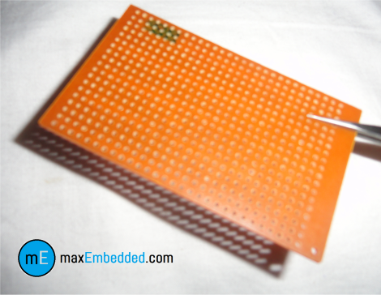

PCB

# Some things you need to know

## IR LED

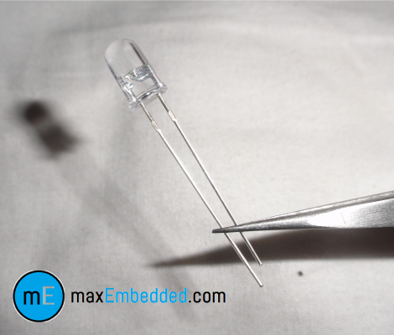

IR LED

An IR LED is a type of LED which emits light in the frequency range of Infra-Red, hence the name ‘IR’ LED. Please note that Infra-Red radiation is invisible to the human eye, and hence we cannot see an IR LED emit it when it actually is. But there is a way to see IR radiations, if you want to. If you look at IR radiation through the lens of a camera, you will be able to see it. Apart from this, in every other sense an IR LED works exactly like an ordinary LED (Look at the picture above), consumes a current of about 20mA and operates on around 3V DC. please refer to the diagram given below for details on connections of the IR LED, as well as the ordinary LED, if you choose to use one.

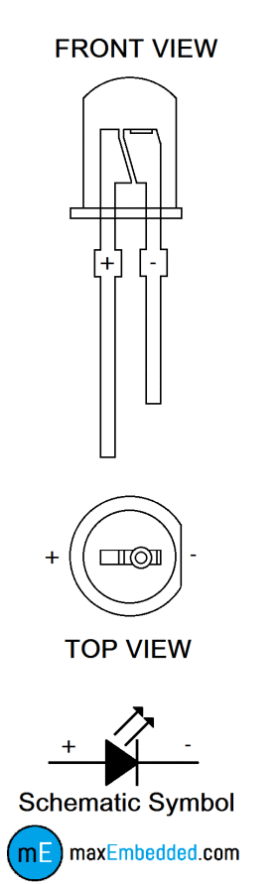

Detailed Diagram of an LED

## Photodiode

A photodiode is a type of diode which detects light. We can think of it as having a very high resistance when no light is falling on it. As we increase the intensity of light incident on it, the current through it gradually increases too. So, by increasing the incident light on a photodiode, we convert it into a normal low value resistor, which conducts current. We should note here that a photodiode looks exactly like an LED, sometimes, with a dark blue or black film on the outer casing (Please look at the picture below), but we make use of it in reverse bias, that means opposite in configuration as in the case of an LED. You can refer to the diagram above for the connections of the photodiode, but remember to connect it in reverse bias as shown in the circuit diagram given in the “How does it work?” section below.

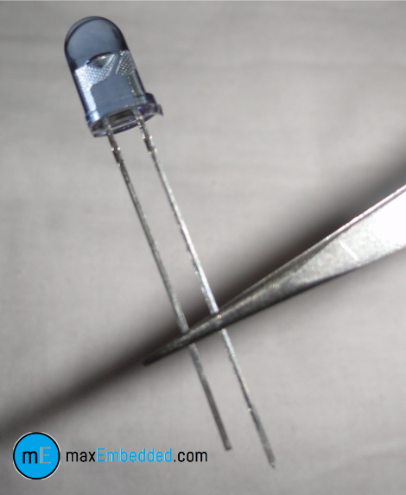

Photodiode

## IC Op-Amp LM358M (as a voltage comparator)

LM358M is a general purpose Dual Operational Amplifier (Op-Amp). Knowing the working of an Op-amp here is really of no use to us, as we are not using it as an amplifier as such, so we will only be talking about how we use it here in the IR sensor circuit, what it does, but not much about how it does it. So basically, we use it to compare two voltages, one is fixed and the other varies with an environmental parameter. If the parameter controlled voltage is higher than the fixed the voltage, then the IC should give one output, and if it is lower than the fixed voltage, then it should give another output. So, we see that the IC gives only two types of outputs, which we design to be 5 Volts and 0 Volts. This makes our sensor digital.

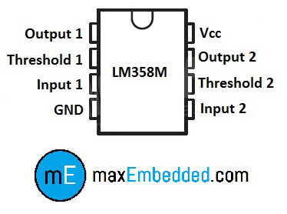

Pin Configuration for LM358M

Now, we know how to use our Op-Amp, so let’s talk about how to connect components to it. This IC is an 8 pin IC. Check the illustration above for the pin layout. Output (pin 1) is where we get the 5/0 Volts, Threshold (pin 2) is the fixed voltage, Input (pin 3) is where we supply our environment controlled voltage, and pin 4 & 8 are used to power up the IC. The best part about this IC is that it is a **Dual Op-Amp**, so you can make two completely separate IR sensors using the same IC! All you need to do is mirror all the connections on the lower three terminals of the other half of the IC (Refer to the pin diagram of the IC).

**NOTE**: The way we are using this IC here and the pin configuration I have shown here is not how an Op-Amp is used traditionally, we are actually manipulating the IC to work as a voltage comparator. Please do not use the above explanation as your guide to studying Operational amplifiers.

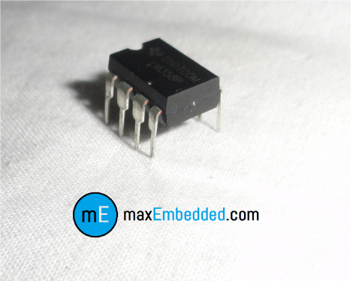

LM358M

## Variable Resistor

A variable resistor is a 3 pin device which is used to vary resistance. In this circuit, we use it to calibrate the IR sensor according to the environment. We give Vcc and GND to the terminals which are close together and connect the center terminal to the threshold of the IC (Assuming you are using the small triangular PCB mountable package like the one shown below).

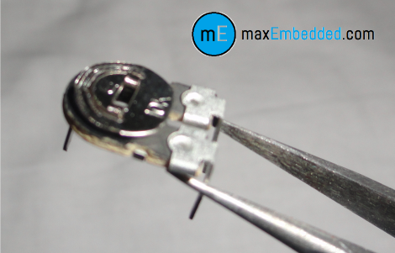

Variable Resistor

# How does it work?

If the IR LED emissions become incident on the photodiode, the photodiode’s resistance comes down to a finite value. The drop across the 10K series resistor is what we use as the input, which is compared with the threshold. The point to be noted here is that more the incident radiation on the photodiode, less will be the drop across it, and hence more will be the drop across the series resistor. If the voltage developed across the resistor is greater than the threshold set by us, the output of the IC will be high, else it will be low. Hence, if our reflected radiation is never strong enough to be greater than the threshold and we have a constant low as output, we can reduce the threshold voltage by turning the “minus shaped” slit in the variable resistance towards its terminal where we connected Gnd. In case our threshold is very low and the output is always high in spite of no radiation or if it is just too sensitive, then you can increase the threshold by turning the slit the other way. When the emissions are absorbed by a black surface, the resistance of the photodiode becomes very high due to no incidence of IR emissions on it, and the output remains low. I like to use an LED to indicate the output, even if I have the output going to the main circuit, but it is totally up to you when you make it.

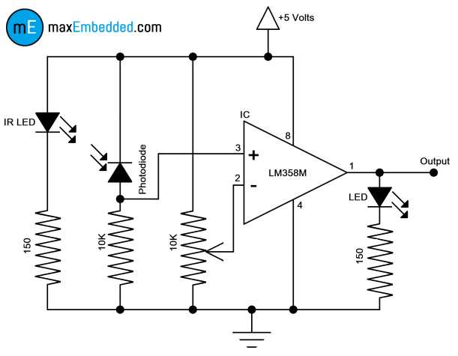

Circuit Diagram

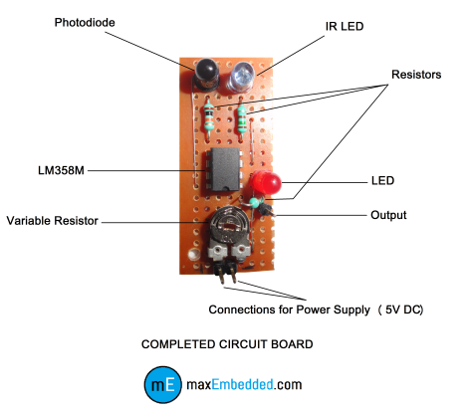

Circuit Discription